JCARE STREET IMPACT PHOTO RELEASE FORM
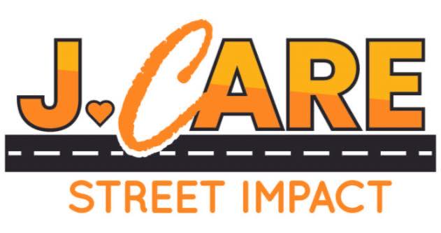

I hereby grant the JCare Street Impact permission to use my likeness in a photograph, video, or other digital media (“photo”) in all its publications, including web-based publications, without payment or other consideration.

I understand and agree that all photos will become the property of JCare Street Impact and will not be returned.

I hereby irrevocably authorize JCare Street Impact to edit, alter, copy, exhibit, publish, or distribute these photos for any lawful purpose. In addition, I waive any right to inspect or approve the finished product wherein my likeness appears. Additionally, I waive any right to royalties or other compensation arising or related to the use of the photo.

I hereby hold harmless, release, and forever discharge JCare Street Impact from all claims, demands, and causes of action which I, my heirs, representatives, executors, administrators, or any other persons acting on my behalf or on behalf of my estate have or may have by reason of this authorization.

I HAVE READ AND UNDERSTAND THE ABOVE PHOTO RELEASE. I AFFIRM THAT I AM AT LEAST 18 YEARS OF AGE, OR, IF I AM UNDER 18 YEARS OF AGE, I HAVE OBTAINED THE REQUIRED CONSENT OF MY PARENTS/GUARDIANS AS EVIDENCED BY THEIR SIGNATURES BELOW. I ACCEPT:

____________________________
Print Name

Signature Date

If under 18, BOTH PARENTS MUST SIGN

Individually and as Parent and/ Date
Legal Guardian

Individually and as Parent and/ Date
Legal Guardian

